An online event management and matchmaking system for board game clubs
Contents
Draft Project Report 2
Background and problem 2
The goal 2
The proposed solution 2
Components 3
Infrastructure 3
Schedule and Risks 4
Literature 6
Project work 7
Outstanding work: 9
Project Review 10
Review of current stage of project work: 10
Review project management: 10
Access risks to project completion: 10
Review of personal development: 10
Reflection after Action: 10
References: 12
Appendix A 13
Appendix B 14
Appendix C 15
Appendix D 17
Appendix E 18
Appendix F 19
Appendix G 22

Draft Project Report

Background and problem
I am an avid board gamer and am a part of a local group that meet weekly in a pub for games, plus other ad hoc meet ups. The weekly evenings starts at 7:30 when there is a roll call of members saying which games they have brought. Once all the games are mentioned, people suggest games to play and form and join groups.
It's only a community group but we can easily get 50-60 people every week, essentially taking over the pub. This means that the roll call is chaotic with people not hearing games mentioned or not knowing what they are, as portrayed by the images in Appendix A. Some people started to use Facebook to pre-arrange games with some using the polling feature. The polling feature has its issues (such as difficult use on mobile devices) and other non-Facebook users feel left out. There is also a problem of new people finding the whole roll call intimidating and some people ending up without a group.

The goal
The goal of this project is to create a method of creating groups and matchmaking players at the start of the night to avoid the chaos of the roll call and to improve the overall experience of the night, making it more inclusive and friendly. It should allow games to begin sooner, extending the time available in the night for members to enjoy themselves. It would support the organisation of pre-arranged and recurring games, as well as games set up on the night.

The proposed solution
My intention is to create a website to allow members to list games that they have available on a particular night and to register interest in playing certain games on that night. Users will sign up and log in to the system in order to register a name and keep a record of their games and events. The user will join one or more particular groups in their area. There will be a page of upcoming events that are in the user’s groups, which the user can view. The system will then show a list of games which other users have proposed to play and allow the user to add some of their own or join other games.
The system would display information about the games, such as a description and the number of players, etc. This would allow members to pre-arrange games and learn more about those games before playing. Later, there would also be the option of more advanced matchmaking methods such as game and player preferences, random games, or skill-based matching. On the night, members would see the list of available games on a big screen in the venue and could register interest in them at that point or add their own games, using their own mobile device or by speaking to another member with access to the website. The games could be announced and then, once interested members have settled on a game (or had the system has been activated to arrange it), they join their table and start the game. Remaining members will easily be able to see what other games are still available to play and with who.
The system would also integrate with the group’s website and social media, sharing details of proposed and arranged games. This would allow new and non-members to be more informed at the start of the night, as well as promoting the events to the public. At a meeting with the user group, this proposal was confirmed by the group leader, as seen in Appendix B.
Utilising my personal and professional knowledge of web development with HTML and JavaScript and expanding upon my level 3 Open University studies in Developing concurrent distributed systems (M362), Ebusiness technologies: foundations and practice (T320) and Fundamentals of interaction design (M364), I intend to develop a multi-tiered, distributed web application which is accessible on a range of devices and by a range of users.

Components
The system can be broken down into four main components:
- User Management – account settings and game preferences
This would provide users with a screen to amend their personal details such as the name, password and preferences for the matchmaking algorithm.
- Event Management – recurring and ad hoc events, e.g. “Tuesday evenings”
This would provide users with a set of screens allowing them to see previous and upcoming events, view any proposed matches and register interest in certain games. Users would also be able to set up their own events that the group can see.
- Game/Library Management – collections of owned and available games in the group
This would provide users with the ability to store a record of the games that they own and might bring to an event, allowing them to more easily add games to events and also for other users to see if a game that they are interested in is own by a member of the group. This library of games could be synchronised with external game library services, such as BoardGameGeek.com.
- Match Management – the actual games being arranged & played
This would provide users with a means of arranging individual play sessions by creating and showing interest in particular games at events.

Infrastructure
In order to make the final application as user-friendly and efficient as possible, I have decided to adopt a Model-View-Controller architecture, where the Model is a representation of the data that a user sees and interacts with, the View is how the user sees and interacts with that data and is updated by the Model, and the Controller is the business logic which manipulates the data, i.e. the Model.
The idea is to separate presentation logic from business logic and presentation state, so that the logic and the presentation can be altered independently without affecting the other. This has the benefit of efficient design in terms of development – the entire codebase does not need to be updated to change either the logic or the presentation.
I have decided to use the AngularJS framework for this purpose because of its simple HTML-expanding design rather than complicated templating engines, which means I do not need to learn even more new languages. Angular actually expands on the capabilities of the Controller and View to enable better user interactions and usable code. This has resulted in it being referred to as MVW, “Model-View-Whatever works for you” (Minar, 2012) because it enables a diverse range of methods to interact with the Model and View, not restricted to Controller types. Angular provides sophisticated but simple data binding between the View and the Model that allows much processing to be handled by the client, freeing resources on the server.
To expand the View component, I have decided to also use JQuery, which is a JavaScript library designed to simplify client-side manipulation of HTML. It is strongly supported by Angular and is widely used on the internet. An alternative would be to use plain JavaScript, which would be able to replicate most of the functionality but with much more effort.
Also, to speed development of prototypes, I am using the Bootstrap library, which includes HTML, CSS and JavaScript templates to create consistent and mobile-friendly websites very quickly, which is important, as a particular use case will be the use of the system on mobile devices at events. There are many alternative CSS frameworks but Bootstrap is widely used, supported and documented, allowing for greater ease of use.
As the Model component, I have decided to use a Node.js server to host the application and act as the service layer of the Model to interact with the database layer. Using Node allows me to finely control access to the data and provide secure business logic. Node is developed in JavaScript, which also means that I am using existing skills rather than learning new languages. Node also has an extensive catalogue of packages which can be easily installed and automatically updated.
On top of the Node server, I have decided to use the Express.js web server framework, which allows simple servers to be set up extremely quickly and easily. It handles the routing of HTTP requests, errors and cookies & sessions. Using Express in this set-up means that there is a wide range of established practices and tutorials, which will speed up development.
Alternatives for the web server could be using PHP or even Go to build the server-side, which may have better performance but would involve re-learning another language before even being able to assess the proper structure of the application. Express makes setting up an HTTP server extremely easy.
For persistence, I have decided to use an online database service, Orchestrate.io, in order to explore the benefits and pitfalls of wider distributed web services. Using a database as a service also means that I do not have to be concerned with the maintenance or scaling of resources, as these are managed by others. The database is considered to be a JSON NoSQL store, which means that data is stored in JavaScript object documents rather than relational tables with rows. This is in order to improve the ease of accessing the data and to reduce the complexity of the database. Again, using a JavaScript-based database means that all the development is in a single main language and all systems are naturally compatible. This is not a free service but, as a student, I have an account with 10 million API requests per month. Significantly more than I expect to need, currently.
A suitable alternative would be MongoDB, another JSON NoSQL database but with more features of a RDBMS. Mongo is commonly used with Node but would involve significantly more maintenance. However, in the future, it may prove beneficial to move to a Mongo-based database.
I will also be using another external data source, BoardGameGeek.com, the de facto resource for board game information, which has details of over 81,000 board games (as of January 25, 2016) and provides an API to access that data. The credibility of this resource could be regarded as higher than Wikipedia, as the public are able to propose changes to the data but any changes are moderated by a team of experienced admins with industry links and game designers and publishers often update their own details, making much of the site first-hand. The reliability is less certain, as I will discuss below.

Schedule and Risks
For planning and management, I am using Project in a Box Planner software, which includes a Gantt chart visualisation of the schedule and also Risk and Issue logs. This is because the package is free and includes brief project management guides for various types of project, from simple to complex. The package is also easy to use but still much more usable and powerful than other free project management tools and templates, such as GanttProject. I wanted to formally record my issues and risks so that I could monitor them and refer to them later.
Below is an updated Gantt chart of the schedule. The initial schedule was far too optimistic and rigid because I would get stuck on a particular problem and move onto something else. It should be more flexible, so the recent schedule has not been any more narrowly defined but rather broadly separated into iterations rather than tasks, which have now been managed under the issues log.
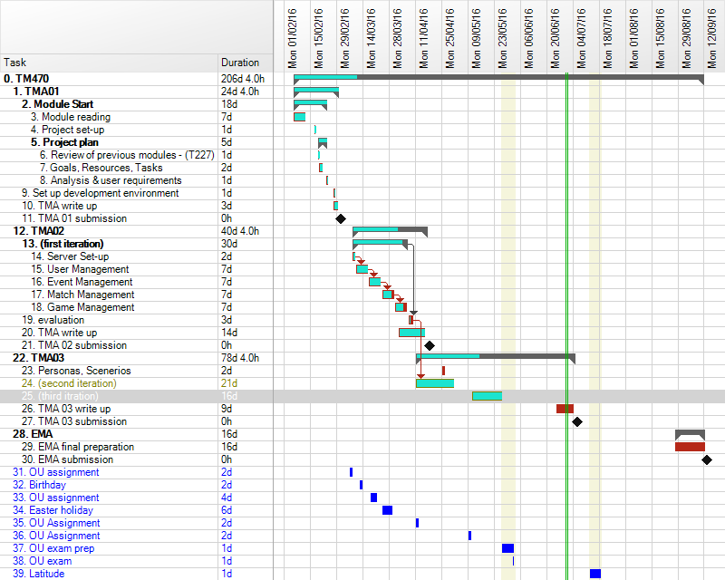
An updated risk table is available below. I have included the likely effects of each risk and sorted them by a rating of the impact and probability. After previous analysis, I had increased the impact and likelihood of risk R8 due to requirements of other OU study and an increased workload at work from starting a new job, plus a related risk R14, because of the unexpected time involved in non-work related activities such as the needs of family and friends, as well as illness over the Easter period. To try to mitigate these risks, I took a much more adaptable approach to the work schedule as mentioned above and tried to work as much as possible, as interruptions were inevitable.
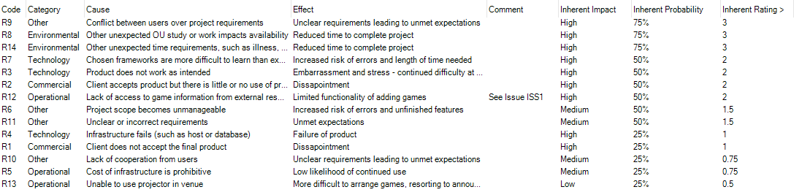
To mitigate the other significant (3 rating) risk, R9, I have stuck to working a on a set of requirements agreed with the user group and based on the initial insight in Appendix B. These requirements have been recorded in the issue log. R2 should also be reduced by this approach.
For the lesser rated (2) risks:
R7, R3 – I have tried to limit the short term scope of the work plan to focus on areas that I am learning, so that the whole frameworks do not seem so daunting.
R12 – There is a significant lack of certainty with the API and service from BGG because, although it is expected that the API (and website in general) would be available for the foreseeable future, the organisers have stated that they could reduce or remove the service at any time, particularly if usage of the API negatively affected the main service if the website. This became apparent on 24 April when the API was not responsive and caused errors is my project. It later became apparent that the service was affected by a site upgrade and the API was a low priority for the administrators. This meant that my application could not retrieve game information.
The negative effect was reduced because the application allows for the manual input of game information but a long term mitigate could be to build a cache of commonly retrieved game data from BGG and store it on my own server, only updating from BGG upon user request or after a certain amount of time. There would need to be more legal and technical considerations of this before implementation.

Literature
Fundamentally, my project is about developing and using web services, so it is very important to expand my understanding of web service architecture and HTTP. To that end, I have found Service Design Patterns: Fundamental Design Solutions for SOAP/WSDL and RESTful Web Services by Robert Daigneau (2011) very useful. The book was found in the Safari Books online collection and is written by a veteran of the online business technology industry less than 5 years ago, which means that it is relatively recent and covers newer topics. The book should help guide me in the right direction to produce an efficient and reliable application.
It has expanded upon my level 3 learning of web services by going into detail about the design of services, including when web services should and shouldn’t be used and the considerations needed to avoid problems. The book describes the various methods and styles of web service APIs and their uses and problems. Even though the book only mentions frameworks for Java and Microsoft C# environments, the theory is still very relevant for my usage of JavaScript. If the application is required to expand and scale, this resource would be invaluable.
As highlighted during my initial discussions with the user group, user interface and experience will be key to the success of this project in order to gain user acceptance. Responsive Web Design with HTML5 and CSS3 by Ben Frain (2012) provides a detailed look at how one can provide a leaner and better experience for users though the approriate use of simple CSS and HTML rather than bulky JavaScript.
I have been using JavaScript Patterns by Stoyan Stefanov (2010) as a very good reference, particularly for working with JSON and asynchronous events. Stefanov is an engineer at Yahoo!, one of the world’s largest services. The text is accessible and obviously written by somebody passionate about clarity and understanding. As the entire application architecture is JavaScript-based, it is important that I learn best practices for the more intricate aspects of the applications, such as the API development and AJAX communication.
To develop my knowledge of asynchronous JavaScript, I found two specific articles extremely informative: By example: Continuation-passing style in JavaScript by Matt Might (Might, 2010) and How do Promises Work? (Quil, 2015). These articles really explained how JavaScript, as a generally single-threaded language, can deal with concurrent applications and have proven very useful for understanding the wider workings of asynchronous requests.

Project work
- Production set-up
After developing the prototype on an integrated development IDE server, I decided to set up a production server in order to assess the capabilities of the application and to start proper testing with the user group. I set up a virtual server on DigitalOcean.com and installed the application from git but it took some time to get it running as I had to refresh my knowledge of basic Linux. After initially setting up the server, I started seeing strange incoming requests in the logs. I then proceeding to include some basic HTTP security settings using the Helmet node package and using some more detailed, persistent logs with the Winston node package. This allowed me to see that the requests were merely web robots crawling the website and should not pose a threat, though I will still need to carefully consider the security of the application before released to the public.
The application has been set up with the Node and Express web server which delivers the static HTML and JavaScript files for Angular as well as the business logic with data pulled from the Orchestrate database API. The user’s web browser loads the static files and the Angular client sends API requests to the Node application and receives the output. Once scaled up, the file server for the static content could actually be hosted on a different server, reducing the direct traffic to the application server and increasing efficiency, like a proxy server. This proxy server could also be replicated around the world to improve responsiveness. Later, the application server and database server could also be replicated.
The DigitalOcean server was selected to be in London and the Orchestrate server was selected to be in Slough, which means that, as the application is aimed at British users initially, there should not be very much latency. The BoardGameGeek server is located in Texas, USA, which causes some delay but is only used intermittently. Moving to the production server greatly decreased the latency to show the pages. A simple diagram of the infrastructure is below, with the dotted line representing the additional intermediary layer for possible proxy servers.
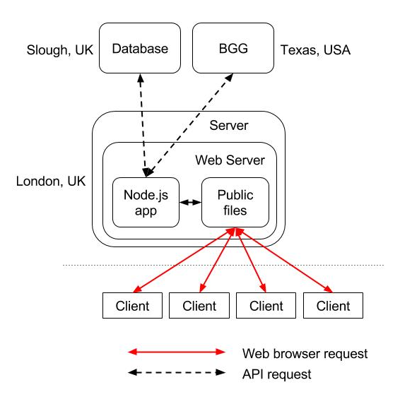
Following the initial success of the production server tests, I proceeded to implement the agreed requirements as listed below:
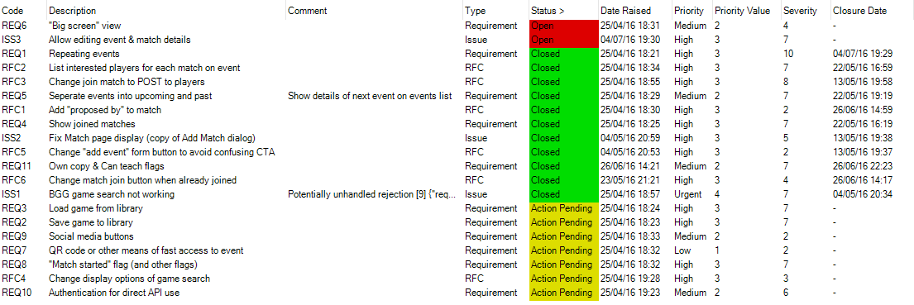
- Promises
Firstly, I implemented a screen to list any matches which a user had joined. This proved challenging because the list shows details of the matches, the players for each match and the event in which that match takes place. This highlighted a significant difference between the NoSQL store that I am using and a traditional SQL-based database, that there are no pre-defined relationships between documents and no easy way of joining queries the way you would in SQL. This meant that I had to retrieve a list of each record and process them on the server but these would be three asynchronous calls to the database which had to be processed in a particular order.
This is where the promises became important. A promise is like a JavaScript IOU for the data that an asynchronous function will retrieve, so that the application does not get blocked while it waits for the response. In order to handle the simultaneous asynchronous calls, I utilised the Kew node package, which provides basic queuing functionality for promises – the Orchestrate API client already used promises so they just had to be managed.
Kew provides an all() function which waits for all promises in an array to resolve before resolving itself. This way I could waiting for all events to be retrieved and all players to be retrieved, then combined with the match list, before sending the response to the client. This is described in Appendix G.
- Repeating events
A key requirement for the application is the ability to have events that repeat on a regular basis, so that they do not need to be created every time. The way that I implemented this was to create an event template that would be used to create new events at each prescribed interval, such as daily, weekly or monthly. The screens can be seen in Appendix C. A function could be run by the system on a regular basis to create these events but it might result in the data being out of date between these updates. Another method is for the function to be run every time the page is loaded, so that the application creates any necessary events when a user requires it. This may require some more processing but is only dependant on users accessing the list of events.
To implement this, the function retrieves all the templates and all the events connected to the templates. It checks each event to see if there is one in the future and if not, creates a new event based on the template details. It then updates the template with a new date to be used in future events. The final list of events is then retrieved. This is described in Appendix F. This will be improved by retrieving only events in the future, if any, for checking the templates but the performance is currently sufficient for testing and development.
This function uses promises in a slightly different way. It still uses a list of promises and all() to wait until all templates have been checked but for each template, but the function utilises the basic method of chaining promises together with the then() function. This catches a fulfilled promise or error from one call and passes onto the next function in the chain. This way each set of asynchronous calls for each template acts as a single call. At the moment, this takes between 200 and 500 milliseconds to process, which will increase as there are more templates but can also be made more efficient.
It has been a challenge to understand the correct usage of promises within the context of this application but it has been rewarding and I hope to improve the efficiency of the current system greatly buy properly utilising them more in the future.

Outstanding work:
Apart from the outstanding requirements listed above, the most significant, outstanding functionality is the matchmaking component. This component should take a list of matches for an event, players’ interest in those matches and the players’ preferences for type of game and determine a final list of matches where every player is assigned to a single match. This should do so without informing other players of any others’ preferences. It should also take into account players who are able to bring a copy of the game and those that can teach the game to new players (including the possibility that a person can teach a game that they are not playing). I have begun to include this functionality on the match screen as seen below:
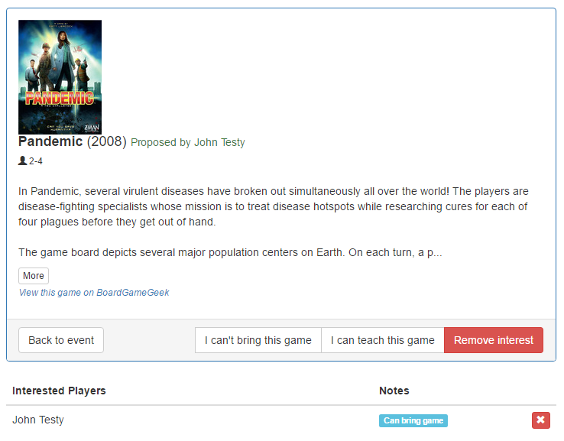

Project Review

Review of current stage of project work:
Due to concerns over my degree classification, I spent more time than planned on revising and preparing for the exam of my other OU module. Although I do feel that I have been successful in that exam, it has been at the expense of my project.
I have found the independent nature of this module over such a period of time gruelling and have lost a lot of interest in the project. This has been worsened because I have attended the group less often in order to continue development, which disconnected me from the users and the vision of the project. I was hoping to be developing the matchmaking component at this point but complexity and time constraints have proved difficult.
I am pleased that I have finally understood most of the promise paradigms and can confidently expand upon their use within the system. I feel that I should have started work on a development server sooner, so that it wasn’t such a shock to be trying to secure a live product without much operational experience. However, I have now gained a great deal of knowledge of git, linux, and server architecture that will enable me to support the application in the future.

Review project management:
Unfortunately, I am not happy with my project management through this period. Although I did begin to use the risk and issue logs with the planner software, I stopped making journal logs and I have felt very demotivated. My scheduling, although flexible, had no real deadlines or incentive.
I had hoped to work within an iterative development model but have just developed whatever I can, whenever I can. In a sense, this has transitioned into a waterfall-type project because the overall requirements have been known for some time and I can just working until I complete them.
Perhaps this is a positive realisation and I should continue with a better roadmap for completion.

Access risks to project completion:
As before, the greatest risk to the completion of the project is external time pressures. Although my other OU work has competed, my work and personal commitments continue to cause problems in my scheduling.

Review of personal development:
Although demotivated, I have still learnt a great amount about asynchronous JavaScript and server management, which should improve the overall effectiveness of the application as well as my career prospects. I should try to utilise this success and continue the momentum into the matchmaking component.

Reflection after Action:
- What went well? What can I learn from that for the rest of my work on this module?
Experimenting with real data helped me understand the complicated nature of promises. I should be more willing to try something practical before becoming disheartened by the complicated theory of something.
- What didn’t go so well? How did I recover from my problems? What can I learn from that for the rest of my work on this module?
Keeping a journal became an after though, which made it more difficult to return to the development after any periods away, thus further contributing to a negative mentality. Taking even very small notes, more often will reduce the load on my mind and hopefully relieve some of the stress of the project.
- Have I reached an acceptable standard, both according to what the module team and my tutor have told me and according to my own judgement?
I believe that, although there is still not much to look at within the application, the backend framework is coming along nicely. In terms of the report, there should still be more written about the risks, as well as reasoning behind decisions, which I hope to include in the future through more note taking.
- Have I met the learning outcomes for this piece of work?
I think that I have met most of the learning outcomes though my project management needs a lot more consideration.
- If not, what am I going to change?
I need to remove the distraction from around me and take time to plan things out on paper without any formal structure – just getting my thoughts onto paper. This should help me visualise the work necessary and help put together a proper schedule.

References:
Daigneau, R. (2012). Service Design Patterns. 1st ed. [ebook] Upper Saddle River, NJ: Addison-Wesley. Available at: http://proquestcombo.safaribooksonline.com.libezproxy.open.ac.uk/9780321669636 [Accessed 29 Feb. 2016].
Frain, B. (2012). Responsive web design with HTML5 and CSS3. Birmingham: Packt Publishing Ltd.
Might, M. (2010). By example: Continuation-passing style in JavaScript. [online] Matt.might.net. Available at: http://matt.might.net/articles/by-example-continuation-passing-style/ [Accessed 14 Apr. 2016].
Montes, L. (2016). bgg. [online] npm. Available at: https://www.npmjs.com/package/bgg [Accessed 13 Apr. 2016].
Quil, (2015). How do Promises Work? - Quils in Space. [online] Robotlolita.me. Available at: http://robotlolita.me/2015/11/15/how-do-promises-work.html [Accessed 14 Apr. 2016].
Stefanov, S. (2010). JavaScript patterns. Sebastopol, CA: O'Reilly.

Appendix A
Images of venue at roll call.
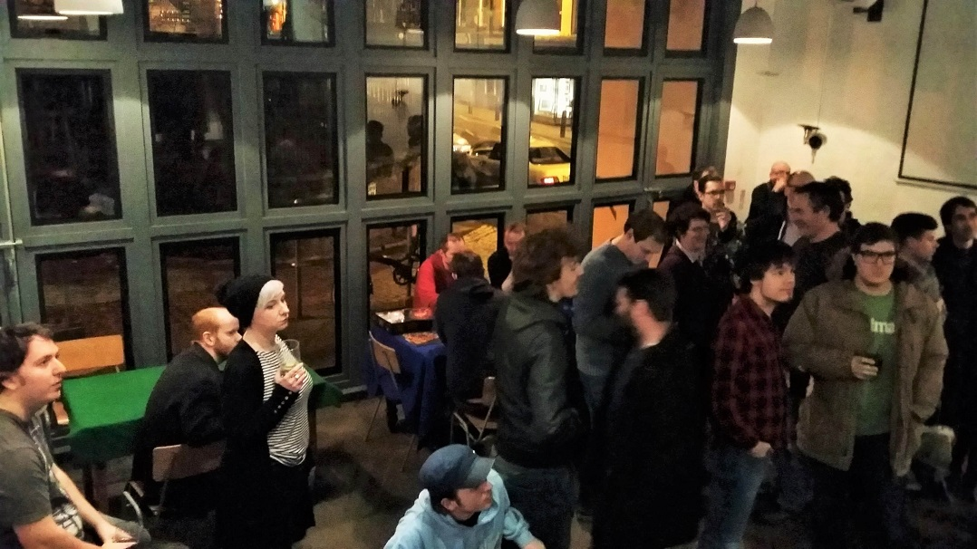

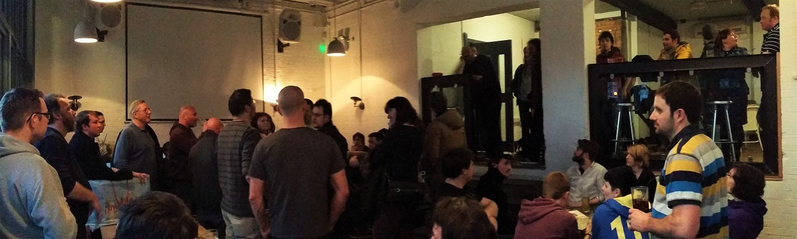

Appendix B
Verbatim comments from discussions with a few core members of the user group.
John, Group Leader:
“Jarryd is making the app as part of his Uni work - and the scope is somewhat up to him, however...
The app needs to address several problems. And when you get into it, there's a lot of user requirements, issues and yada for our group. There's a balancing act of allowing people to organise tricky to get to table games with known players and also being welcoming to new people and not just having a cliquey Youre Not From Around Here cold shoulder thing going on, AND addressing social anxiety issues, and unfamiliarity, and yada yada yada. ( Headache ).
But basically game organising that is -
1) Inclusive of *everyone*. Particularly new people and those who want least fuss.
2) Allow good organisation of pre-arranged games.
3) Allow good organisation of games on game night.
Also the point of all this is to let the system / computer do the management. If someone is having to babysit a process it's a failure.
All you really need is a central list of available games, and people can vote on what they want to play. The particulars of that list break down into pre-arranged games, so games that go up on a list before game night. And then games that turn up adhoc on game night and are visible to everyone - either via their mobile device, OR, and here's the kicker, available through a large public display.
Ideally what you want is an app that allows a given user to keep a record of whatever games they have. Flag them to be pre-arranged or not. Or flag them as games I am bringing with me this week. Voting to play a game is as simple as clicking on a game in the list, which will mark you as voted, and on game night when the process is resolved, the system will tell you what you're playing based on a bunch of voting weights.
On game night the whole thing should be available from a large public display ( via hooking any device up to a chromecast ) - which allows new people to see whats available to play as well as those who dont buy into the app process to still interact with whats going on.
Effectively you move game organising into an on screen digital space. To the refuseniks or new it will be better than a roll call - no having to shout what you have or failing to hear what others have. To those who do buy into it they will get a way to browse whats available AND - cool thing - be able to read what a game actually is if they dont know ( which is most of the time ) via a click.
As for being available for other gaming groups, yeah, sure, very possible in theory. Development is somewhat Jarryds thing atm as he's doing it to fulfill course requirements. So. It may or may not be a workable prototype. Plus theres an issue of user buy in - if no one is interested its not going to work out, but, casting it onto a big screen guarantees its at least somewhat fit for purpose as it will replace a game roll call.”
Pete
“The interface and experience is key to user buy-in and acceptance – nothing should be complicated or time-consuming. The app should be able to take a user’s secret preferences of other players to play with or avoid. “

Appendix C
Add Repeating event
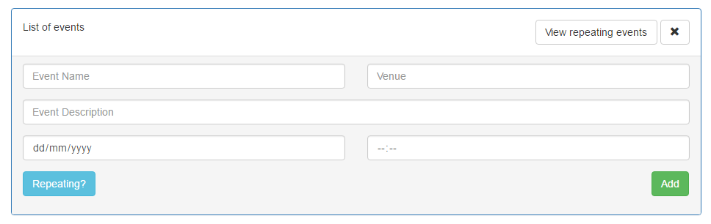
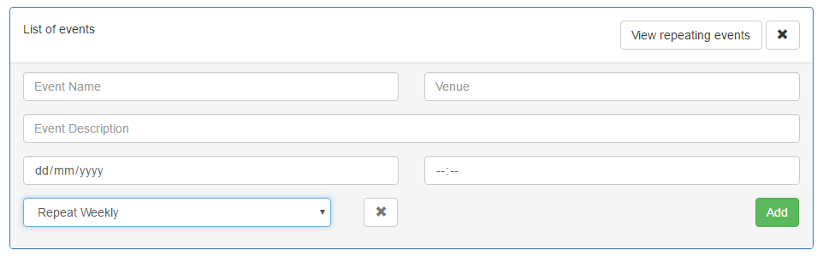
List of events:
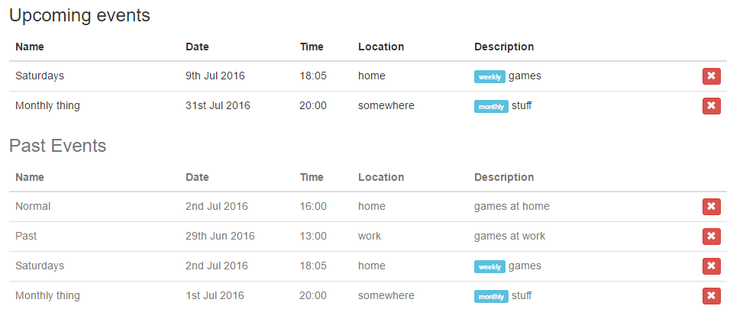
Repeating match templates:
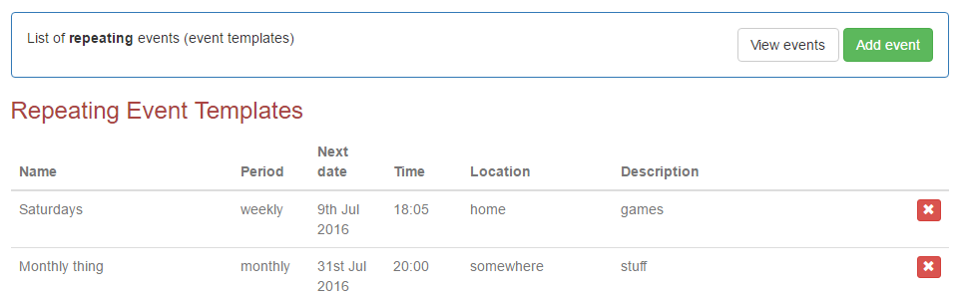

Appendix D
Work Breakdown Schedule of tasks, including % complete
ID | WBS Code | Name | Start | Finish | Duration | % Complete
0 |  | TM470 | 06/02/2016 | 12/09/2016 | 206d 4.0h | 10.4
1 | 1 | TMA01 | 06/02/2016 | 01/03/2016 | 24d 4.0h | 100
2 | 1.1 | Module Start | 06/02/2016 | 24/02/2016 | 18d | 100
3 | 1.1.1 | Module reading | 06/02/2016 | 12/02/2016 | 7d | 100
4 | 1.1.2 | Project set-up | 17/02/2016 | 17/02/2016 | 1d | 100
5 | 1.1.3 | Project plan | 19/02/2016 | 24/02/2016 | 5d | 100
6 | 1.1.3.1 | Review of previous modules - (T227) | 19/02/2016 | 19/02/2016 | 1d | 100
7 | 1.1.3.2 | Goals, Resources, Tasks | 19/02/2016 | 21/02/2016 | 2d | 100
8 | 1.1.3.3 | Analysis & user requirements | 23/02/2016 | 24/02/2016 | 1d | 100
9 | 1.2 | Set up development environment | 27/02/2016 | 28/02/2016 | 1d | 100
10 | 1.3 | TMA write up | 27/02/2016 | 29/02/2016 | 3d | 100
11 | 1.4 | TMA 01 submission | 01/03/2016 | 01/03/2016 | 0h | 100
12 | 2 | TMA02 | 05/03/2016 | 17/04/2016 | 43d 4.0h | 35
13 | 2.1 | Personas, Scenerios | 05/03/2016 | 06/03/2016 | 2d | 0
14 | 2.2 | Initial Wireframes | 07/03/2016 | 07/03/2016 | 1d | 0
15 | 2.3 | (first iteration) | 08/03/2016 | 06/04/2016 | 30d | 90
16 | 2.3.1 | Server Set-up | 08/03/2016 | 09/03/2016 | 2d | 100
17 | 2.3.2 | User Management | 10/03/2016 | 16/03/2016 | 7d | 100
18 | 2.3.3 | Event Management | 17/03/2016 | 23/03/2016 | 7d | 100
19 | 2.3.4 | Match Management | 24/03/2016 | 30/03/2016 | 7d | 80
20 | 2.3.5 | Game Management | 31/03/2016 | 06/04/2016 | 7d | 70
21 | 2.4 | evaluation | 07/04/2016 | 09/04/2016 | 3d | 50
22 | 2.5 | TMA write up | 02/04/2016 | 16/04/2016 | 14d | 70
23 | 2.6 | TMA 02 submission | 17/04/2016 | 17/04/2016 | 0h | 0
24 | 3 | TMA03 | 11/04/2016 | 05/07/2016 | 78d 4.0h | 0
25 | 3.1 | (second iteration) | 11/04/2016 | 01/05/2016 | 21d | 0
26 | 3.2 | (third itration) | 11/05/2016 | 27/05/2016 | 16d | 0
27 | 3.3 | TMA 03 write up | 25/06/2016 | 04/07/2016 | 9d | 0
28 | 3.4 | TMA 03 submission | 05/07/2016 | 05/07/2016 | 0h | 0
29 | 4 | EMA | 27/08/2016 | 12/09/2016 | 16d | 0
30 | 4.1 | EMA final preparation | 27/08/2016 | 12/09/2016 | 16d | 0
31 | 4.2 | EMA submission | 12/09/2016 | 12/09/2016 | 0h | 0
32 | 5 | OU assignment | 07/03/2016 | 08/03/2016 | 2d | 0
33 | 6 | Birthday | 12/03/2016 | 13/03/2016 | 2d | 0
34 | 7 | OU assignment | 18/03/2016 | 21/03/2016 | 4d | 0
35 | 8 | Easter holiday | 24/03/2016 | 29/03/2016 | 6d | 0
36 | 9 | OU Assignment | 11/04/2016 | 12/04/2016 | 2d | 0
37 | 10 | OU Assignment | 09/05/2016 | 10/05/2016 | 2d | 0
38 | 11 | OU exam prep | 27/05/2016 | 02/06/2016 | 1d | 0
39 | 12 | OU exam | 02/06/2016 | 02/06/2016 | 1d | 0
40 | 13 | Latitude | 13/07/2016 | 19/07/2016 | 1d | 0

Appendix E
List of Git commits
b489039 - Sat Jul 2 17:14:14 2016 : fixed promises for adding repeat events!
62e60e2 - Tue Jun 28 09:10:37 2016 : added moment to package.json
bb0b9e9 - Tue Jun 28 09:08:24 2016 : updating repeating events
b86a0d5 - Mon Jun 27 22:23:39 2016 : add 1st version of repeating events
1079c15 - Sun Jun 26 21:18:56 2016 : Added flags for bringing and teaching games
c1ad08a - Sun Jun 26 13:23:24 2016 : added Remove from match
5b7a319 - Mon May 23 15:02:30 2016 : re-added logging for static files
ade16f4 - Mon May 23 14:53:07 2016 : removed next() from wildcard route, causing 404
6323a6a - Mon May 23 12:02:52 2016 : moved logfile to root
3ecd8f8 - Mon May 23 09:05:17 2016 : added persistant logging with Winston
4daad40 - Sun May 22 18:59:35 2016 : added myMatches and fixed promises with kew
e08f741 - Thu May 12 21:51:15 2016 : final testing git stuff
bf31e53 - Thu May 12 20:26:19 2016 : hard coding port 80
1b0e526 - Thu May 12 20:12:01 2016 : fixing git/live server
0ef2514 - Thu May 12 18:03:55 2016 : adding in Git tags for checking current LIVE version
03367cf - Fri May 6 20:08:35 2016 : fixes and updates

4af8dad - Wed Apr 27 19:50:10 2016 : game search fixes and final TMA02 work
80e0955 - Wed Apr 13 22:26:56 2016 : work on bgg game searching and match display
4d36155 - Sun Apr 10 19:48:44 2016 : added joining matches
846eb72 - Sun Apr 10 17:44:49 2016 : added match & event deletion for admin users
f5de992 - Fri Apr 8 21:00:01 2016 : added getGameDetails ajax calls
df344ab - Thu Apr 7 23:34:23 2016 : fixed username check and added comments
067bcf4 - Wed Apr 6 22:48:05 2016 : added BGG game look up when adding matches!
2a6f1fe - Wed Apr 6 21:15:04 2016 : updated readme
9ba10e2 - Wed Apr 6 21:07:21 2016 : added event and match viewing and adding
9772aae - Tue Apr 5 20:02:18 2016 : continued work on auth
3a7bdf6 - Thu Mar 31 20:31:21 2016 : moth auth work, including adding hash/salted passwords
a9ce424 - Thu Mar 31 14:52:03 2016 : adding more logging info
c449e81 - Wed Mar 30 23:45:11 2016 : fix
4d6c2aa - Wed Mar 30 23:38:26 2016 : additions
9eaf3ab - Wed Mar 30 23:33:33 2016 : fixes to auth and account update screen
2facbd7 - Wed Mar 30 19:15:40 2016 : more auth work
038f13a - Wed Mar 30 16:49:34 2016 : fixing routing
346a530 - Wed Mar 30 16:15:26 2016 : Started looking at front-end and moved bower_components to public
b1b84dd - Tue Mar 8 18:48:09 2016 : Completed signup test and "checkuser"
6bb4890 - Mon Mar 7 20:10:12 2016 : Testing out signup
861396f - Sat Mar 5 15:47:22 2016 : Installed Angular seed files
6360371 - Sat Mar 5 15:37:47 2016 : Implementing basic Passport authentication
b636b2b - Fri Mar 4 22:32:17 2016 : Installed bootstrap and started testing passport authentication
b7ed539 - Tue Mar 1 17:47:54 2016 : Installed Passport and Angular-socket-io
e3af556 - Mon Feb 29 22:16:38 2016 : Installed BGG library and tested api
8b71801 - Mon Feb 29 21:19:39 2016 : installed Socket.io
10fb730 - Sun Feb 28 20:54:51 2016 : Final init
c3f19de - Sun Feb 28 19:10:11 2016 : Added Angular and Readme
a9555aa - Sun Feb 28 18:45:14 2016 : Initial set-up

Appendix F
Promises for repeating events
routerAPI.get('/events/', //get all events
//require('connect-ensure-login').ensureLoggedIn('/login'),
function(req, res){
if(!req.user){
console.error("not logged in");
res.status(403).send("not logged in");
}
else{
//First check for new repeating events
db.list('Repeating', {limit: 100}) //GET ALL REPEATING RECORDS
.then(function (repeatResult) {
var repeatPromises = [];
if(repeatResult.body.count > 0){
for(var x in repeatResult.body.results){ //GO THROUGH ALL RECORDS
repeatPromises.push(db.newGraphReader() //GET ALL LINKED EVENTS
.get()
.from('Repeating', repeatResult.body.results[x].path.key)
.related('events')
.then(function (eventResult) {
var newEvent = {};
var newDate = "";
var repeat = repeatResult.body.results[x].value.repeat;
var period = "";
if(repeat == "daily"){ period = "d";}
else if(repeat == "weekly"){ period = "w";}
else if(repeat == "monthly"){ period = "M";}

if (typeof eventResult.body.results !== 'undefined' && eventResult.body.results.length > 0) {
var eventExists = false;
for(var i in eventResult.body.results){ //GO THROUGH ALL EVENTS
var theDate = moment(eventResult.body.results[i].value.date);
var now = moment();
if(now.isBefore(theDate.subtract(1, "d"))){ //CHECK TO SEE IF AN EVENT EXISTS IN THE FUTURE (NOT INCLUDING TODAY)
eventExists = true;
}
}
}
if(!eventExists){ //NO FUTURE EVENT SO CREATE ONE
newEvent = eventResult.body.results[i].value; //COPY EVENT DATA FROM TEMPLATE
newDate = moment(repeatResult.body.results[x].value.date).add(1, period).toDate();
newEvent.date = newDate;
console.log("new repeating event to be added for: " + repeatResult.body.results[x].value.name + " - " + newDate);
return newEvent; //pass event on to next then() function
}
else{
throw "no events needs to be added"; //reject promise
}
})
.then(function(event){
if(event){
return db.post('Events', event) //ADD NEW EVENT
.then(function (newEventResult) {
event.key = newEventResult.path.key;
return event; //pass event on to next then() function
})
.fail(function(error){
throw "post fail: " + error.body.message; //reject promise
});
}
else{
return false;
}
})
.then(function(event){
if(event){
return db.newGraphBuilder() //CREATE LINK FROM TEMPLATE TO EVENT
.create()
.from('Repeating', repeatResult.body.results[x].path.key)
.related('events')
.to('Events', event.key)
.then(function (newEventLinkResult) {
return event; //pass event on to next then() function
})
.fail(function(error){
throw "link fail: " + error.body.message; //end promise
});
}
else{
return false;
}
})
.then(function(event){
if(event){
return db.newPatchBuilder('Repeating', repeatResult.body.results[x].path.key) // UPDATE TEMPLATE
.replace('date', event.date)
.apply()
.then(function (result) {
// All changes were applied successfully
return true; //FINAL PROMISE RETURN
})
.fail(function(error){
throw "patch fail: " + error.body.message; //reject promise
});
}
else{
throw "promise fail"; //SOMETHING WENT WRONG?
}
})
.fail(function(err){
console.error(err);
return false; //FINAL PROMISE RETURN (FAIL)
})
);
}
}
else{
console.log("no repeating");
repeatPromises.push(true);
}
Q.all(repeatPromises) //ONLY GET EVENTS AFTER THE REPEATING TEMPLTATES HAVE BEEN CHECKED
.then(function (content) {
//content contains the results of the promises true for event created or no templates and false for fail/no creation needed
//I think this could contain more details rather than true/false
console.log("list all events");
db.list('Events', {limit:100}) //will eventually change to accomodate multiple organisations - should change to a search!
.then(function (result2) {
if(result2.body.count == 0){
console.log("no events found");
res.status(200).send("no events found");
}
res.send(result2.body);
})
.fail(function (err) {
console.log("error : " + err.body.message);
console.log("count=" + err.body.count);
res.send(err);
});
});
})
.fail(function (err) {
console.log("error : " + err.body.message);
console.log("count=" + err.body.count);
});
}
});

Appendix G
“My matches”
promisesCombined.push(Q.all(promises) //create a promise for the completion of the event Promises
.then(function (content) {
for(var i in matchlist){
matchlist[i].value.date = content[i].body.date;
matchlist[i].value.eventName = content[i].body.name;
}
return true;
})
);

promisesCombined.push(Q.all(promises2) //create a promise for the completion of the player Promises
.then(function (content) {
for(var i in matchlist){
matchlist[i].value.players = content[i];
}
return true;
})
);

Q.all(promisesCombined) //all promises are now complete (returned true), so send response
.then(function (content) {
res.send(matchlist);
})
.fail(function (err) {
console.log("player error : " + err);
});

